Annual Sports Report 2023 -2024

# College Name: Durgapur women’s college

Date: 19.12.2023

Prepared by: [convenor of sport’s committee]

# Table of Contents

Introduction

Objectives

Overview of Events

Highlights and Achievements

Participation and Attendance

Event Organization

Conclusion

Appendices

**Introduction**

# The Annual Sports Event at Durgapur Women’s College is a highly anticipated and celebrated occasion, fostering a spirit of camaraderie, sportsmanship, and healthy competition among students and staff. This event, held every year, aims to promote physical fitness, enhance teamwork, and provide a platform for showcasing athletic talents within our college community.

# This year's event, held on 19.12.2022 was a remarkable success, drawing enthusiastic participation from students across various disciplines. The event featured a diverse range of sports activities, including athletics, team sports, and individual competitions, ensuring an inclusive and engaging experience for all participants.

# The significance of the Annual Sports Event extends beyond the realm of physical activity; it serves as a crucial opportunity for personal development, fostering leadership skills, resilience, and a sense of achievement. This report aims to provide a comprehensive overview of the event, highlighting key achievements, participation statistics, organizational details, and feedback, while also offering recommendations for future improvements.

# Top of Form

# Bottom of Form

### Objectives

### The Annual Sports Event at Durgapur Women’s College was organized with the following key objectives:

* **Promote Physical Fitness** Encouraging students and staff to engage in regular physical activity is vital for fostering a culture of health and wellness within the college community. By providing a structured environment for various sports activities, the event aims to highlight the importance of staying active and maintaining a healthy lifestyle. This, in turn, helps in reducing stress, improving mental health, and enhancing overall physical well-being.
* **Foster Teamwork and Sportsmanship** One of the core objectives of the annual sports event is to develop teamwork and cooperative skills among participants. Through team-based sports and activities, students learn the value of collaboration, effective communication, and strategic thinking. The emphasis on fair play and mutual respect ensures that participants understand the importance of integrity and ethical behavior in all aspects of life, both on and off the field.
* **Provide a Platform for Showcasing Talents** The event serves as a stage for students to display their athletic abilities and be recognized for their achievements. By celebrating the successes of our athletes, we aim to inspire others to pursue excellence in sports. This recognition not only boosts the confidence of the participants but also fosters a competitive spirit that drives continuous improvement and personal growth.
* **Enhance Social Interaction** The annual sports event facilitates interaction and bonding among students from different disciplines. By bringing together a diverse group of participants, the event promotes socialization and the exchange of ideas, contributing to a sense of unity and college spirit. This enhanced social interaction helps in building lasting friendships and a supportive community within the college.
* **Identify and Nurture Potential Talent** Identifying promising athletes who can represent the college in inter-collegiate and national-level competitions is another key objective. The event provides a platform for scouting and recognizing talent, allowing the college to offer support and training to these individuals. By nurturing their skills, we aim to help them reach their full potential and bring pride to the college through their achievements in the wider sports arena.
* **Encourage Participation and Inclusivity** Ensuring a wide range of sports and activities to accommodate diverse interests and abilities is crucial for encouraging maximum participation. The event is designed to be inclusive, offering opportunities for everyone to get involved, regardless of their skill level or previous experience. This inclusivity fosters a welcoming environment where all students feel valued and motivated to take part in physical activities.

These objectives reflect our commitment to the holistic development of our students, integrating physical education into the broader educational experience and contributing to their overall well-being and personal growth.

**Overview of Events:**

The Annual Sports Event at Durgapur Women’s College featured a diverse range of sports and activities, designed to engage participants across various interests and skill levels. The event happened on 23.12.2022 and included both traditional athletic competitions and fun, unconventional games. Here is an overview of the key events:

* **100 Metres Run** The 100 metres run is a classic track event that tests the speed and endurance of participants. This highly anticipated race drew significant attention, with participants competing fiercely to achieve the best time. The event highlighted the athletic prowess of our students and set the tone for the competitive spirit of the sports meet.
* **Spoon Marble Race** The spoon marble race added a fun and challenging twist to the event lineup. Participants had to balance a marble on a spoon and race to the finish line without dropping it. This activity tested the participants’ focus, balance, and coordination, providing an enjoyable yet competitive experience for everyone involved.
* **Slow Cycle Race** Unlike typical cycling races, the slow cycle race required participants to ride their bicycles as slowly as possible without losing balance or touching the ground. This event emphasized control and balance, offering a unique and entertaining challenge that amused both participants and spectators alike.
* **Passing the Ball** The passing the ball event was a team-based activity that promoted teamwork and coordination. Participants had to pass a ball along a line of team members without dropping it, aiming for speed and accuracy. This event was a testament to the collaborative spirit of our students and underscored the importance of working together to achieve common goals.
* **Shot Put**

The shot put throw event was a highlight, showcasing the strength, technique, and competitive spirit of participants. Participants competed to launch a heavy spherical object, known as a shot, using a pushing motion from within a throwing circle. This event not only emphasized physical strength but also required precise coordination and technique to achieve maximum distance.

* **Go As You Like**

"Go As You Like" is a fancy dress competition where participants dress up and perform as any character or personality of their choice. It is a popular event in school and college festivals, encouraging creativity and imagination.

# Each of these events contributed to a well-rounded and dynamic sports meet, ensuring there was something for everyone to enjoy and participate in. The combination of traditional and unconventional sports activities not only fostered a spirit of competition but also created a fun and inclusive atmosphere for all attendees.

# 

# Highlights and Achievements:

# Results and Winner:

# 100 Meter Run

# First Place: [Sandita Besra (Political Science )]

# Second Place: [Shreya Maji (Psychology)]

# Third Place: [Anjali singh(English)]

# Spoon Marble Race

# First Place: [Tanu Bagdi (Bengali)]

# Second Place: [Rima Das (History)]

# Third Place: [Sejal Rohila (Hindi)]

# Slow Cycle Race

# First Place: [Rupa Debnath (English)]

# Second Place: [Nisha Ghosal (English)]

# Third Place: [Aditi Shaw (Englsih)]

# Passing the Ball

# First Place: [Pratusha Mitra (Chemistry)]

# Second Place: [Khushi Mondal(psychology)]

# Third Place: [Anjali Gupta (History)]

# Shot Put

# First Place: [Anita Kumari (Hindi)]

# Second Place: [Madhumita mondal (Bengali)]

# Third Place: [Swiata Mahato (Economics)]

**Go As you Like**

# First Place: [Diya Maity & Anjali Singh (English)]

# Second Place: [Suparna Chakraborty & Paramita Mondal (Chemistry)]

# 5. Participation and Attendance

# The Annual Sports event at our college witnessed enthusiastic participation and significant attendance, highlighting the event's popularity and importance within our community.

# Participant Overview

# Total Participants: 150 students

# Events:

# Athletics: 60 participants

# Team Sports: 50 participants

# Individual Sports: 40 participants

# Event-wise Participation

# 100 Meter Run: 30 participants

# Spoon Marble Race: 25 participants

# Slow Cycle Race: 25 participants

# Passing The Ball: 40 participants

# Shot Put: 30 participants

# Attendance

# Spectators: Over 170 attendees

# Faculty and Staff: 30 members

# Guests and Alumni: 20 individuals

# Highlights

# The 100 Meter Run had the highest number of participants, showcasing intense competition and excitement.

# The Musical Chair event was particularly popular among both participants and spectators, providing a fun and engaging experience.

# The active participation and high attendance underscore the community’s enthusiasm for sports and physical activities, contributing to a vibrant and energetic atmosphere throughout the event.

# 6.Event Organization

# The successful organization of the annual sports event required meticulous planning and coordination by various committees and teams. Here is a detailed account of the event organization:

# Committees Involved and Their Roles

# Organizing Committee:

# Comprised of senior faculty members and student representatives.

# Responsible for overall planning, coordination, and execution of the event.

# Set objectives, themes, and schedules for the event.

# Logistics Committee:

# Managed the transportation and accommodation of participants.

# Ensured the availability of sports equipment and materials.

# Coordinated with vendors for the setup of the venue, sound systems, and seating arrangements.

# Sports Committee:

# Planned and supervised all sports activities.

# Coordinated with referees, judges, and coaches for fair and smooth conduct of events.

# Prepared event schedules and ensured adherence to timelines.

# Finance Committee:

# Prepared and managed the budget for the event.

# Handled all financial transactions, including sponsorships and

# 7.Conclusion:

# The annual sports event at Durgapur Women’s College was a resounding success, leaving a lasting impact on the college community. The enthusiasm and participation from students, staff, and spectators were remarkable, creating a vibrant and competitive atmosphere throughout the event.

# The primary objectives of promoting physical fitness, fostering teamwork, and providing a platform for showcasing talents were achieved effectively. Participants displayed exemplary sportsmanship, and many showcased their skills, setting new records and achieving personal bests.

# The event was meticulously organized, thanks to the dedicated efforts of the planning committee and the support of various volunteers. Safety protocols were strictly followed, ensuring a secure environment for all participants and spectators.

# Financially, the event was well-managed, with the budget being utilized efficiently. Sponsorships and revenue generated helped in covering expenses, and the financial summary reflects a well-balanced expenditure.

# Feedback from participants and attendees was overwhelmingly positive, highlighting the smooth organization and the enjoyable experience. However, some areas of improvement were identified, such as better timing coordination and enhanced facilities for certain events. These recommendations will be invaluable for planning future events.

# In conclusion, the annual sports event not only celebrated the spirit of sportsmanship and competition but also strengthened the sense of community within the college. It provided an opportunity for individuals to connect, compete, and celebrate their achievements together. The success of this event sets a high standard for future sports events, and we look forward to organizing even more engaging and inclusive activities in the years to come.

# 8.Appendices

Include any additional material such as:

1. Event schedule.
2. Photographs from the event.
3. Financial statement

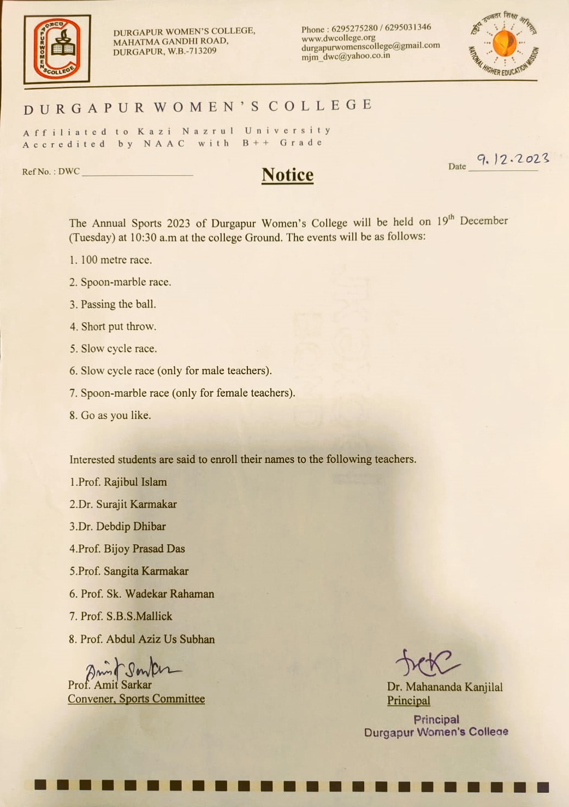  
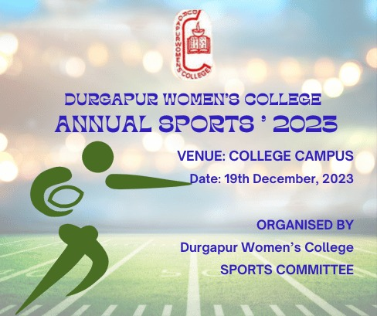

# Top of Form

# Bottom of Form



